**Entry # _________________________________**

*filled in by museum staff*  
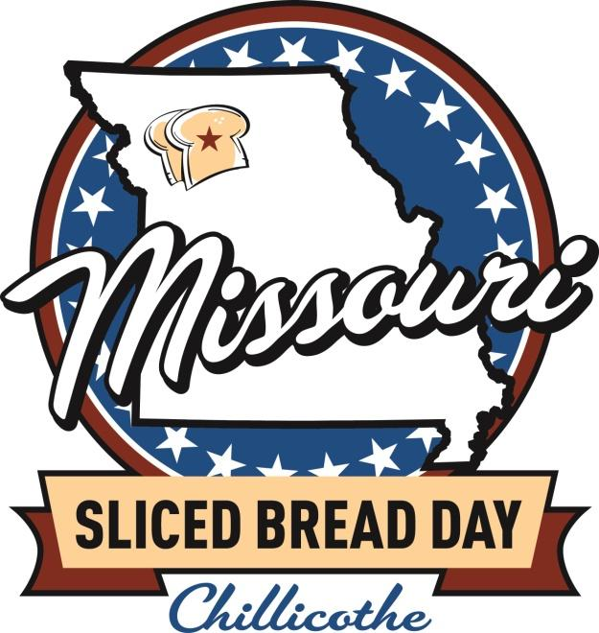 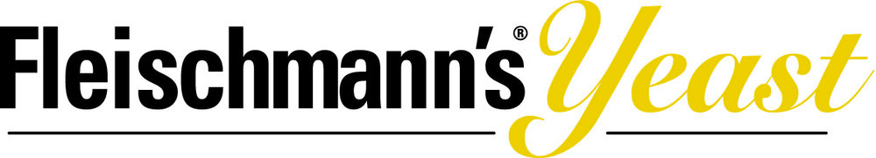 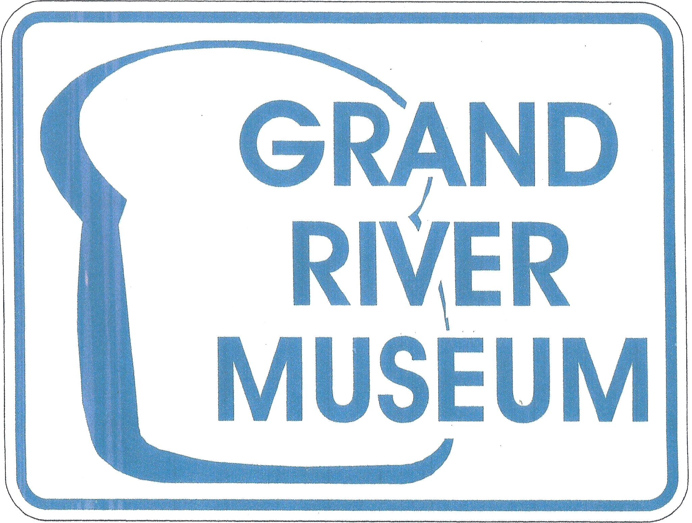

| **Entry Form** | |
| --- | --- |
| **Name:** | **one** |
| **Address:** | **one** |
| **Phone:** | **one** |
| **Email:** | **one** |
| **Division (circle 1):** | **Senior (18 and older) Youth (Under 18)** |
| **Format (circle 1):** | **Yeast Bread Sweet Bread Savory Bread** |
| **Name of Bread:** | **one** |

**Rules: All bread must be home-made, and must use “from scratch” ingredients. No bread machine loaves or boxed mixes will be considered. We will accept one loaf per entry form for judging, but you may submit more than one entry form/bread.**

**Recipes must be included with your entry form (handwritten or printed documents 8.5x11”, please no print outs from websites) including any alterations made.**

**It is possible that some breads will not be eaten if it is deemed unsafe for judges to do so. Our judges are volunteers, but their decisions are final. If you have questions regarding the event or the judging you may call the museum at 660-646-1341.**

**This form confirms agreement that my name may be published as a winner and for photos of my bread to be used in social media or other news media. Entrants do not need to be present to win. In each age division: First prize is $50, Second prize is $25, Third prize is $10 in each of three categories. 2 age divisions x 3 categories x 3 prizes = 18 prizes.**

**I agree: ___________________________________________________________________________________________________**

| **Thank** You**!** | June 7, 2025, Saturday  8am to 10am: Drop off of entries  10am to 12pm: Judging (private)  After 1pm: Public slicing and sampling |
| --- | --- |